**WEEK 9**

**Mid Term**



**Name**

Sherly Lutfi Azkiah Sulistyawati

**NIM**

2341720241

**Class**

1I

**Major**

Information Technology

**Study Program**

D4 Informatics Engineering

|  |
| --- |
| Item |
| itemCode: int  name: String  category: String  stock: int |
| Item(itemCode: int, name: String, category: String, stock: int)  toString(): String |

|  |
| --- |
| StockManagement |
| listItem: item[]  idx: int |
| addItem(item: Item): void  displayAllItems(): void  sortItemsByStock(): void  displayFoodItemsWithNoStock(): void  searchItemByName(keyword: String): void  addStock(itemCode: int, quantity: int): void  decreaseStock(itemCode: int, quantity: int): void |

Item Class

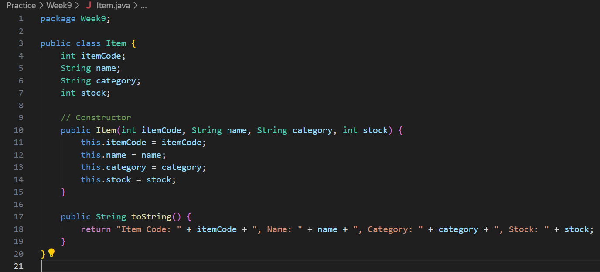

StockManagement Class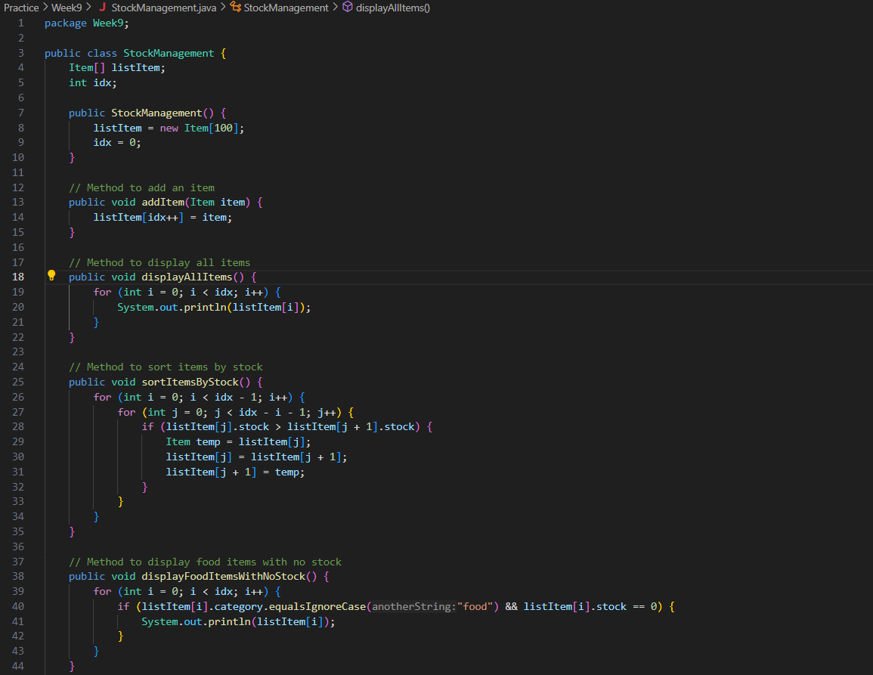 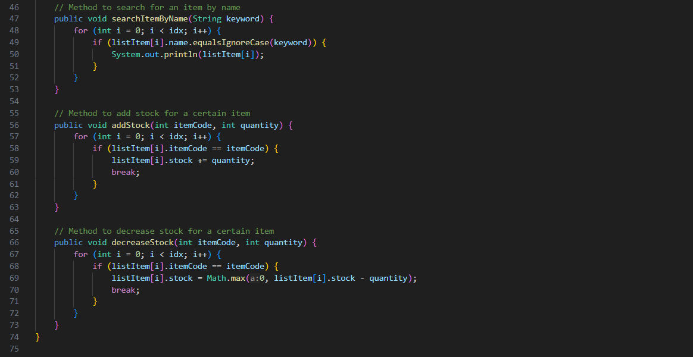

StockManagementMain Class

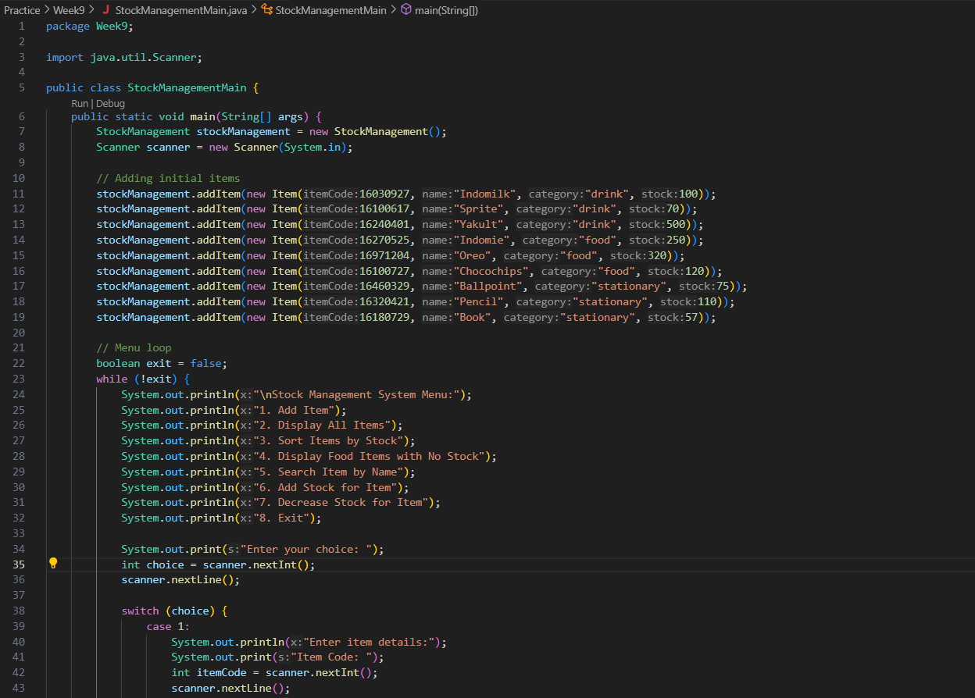 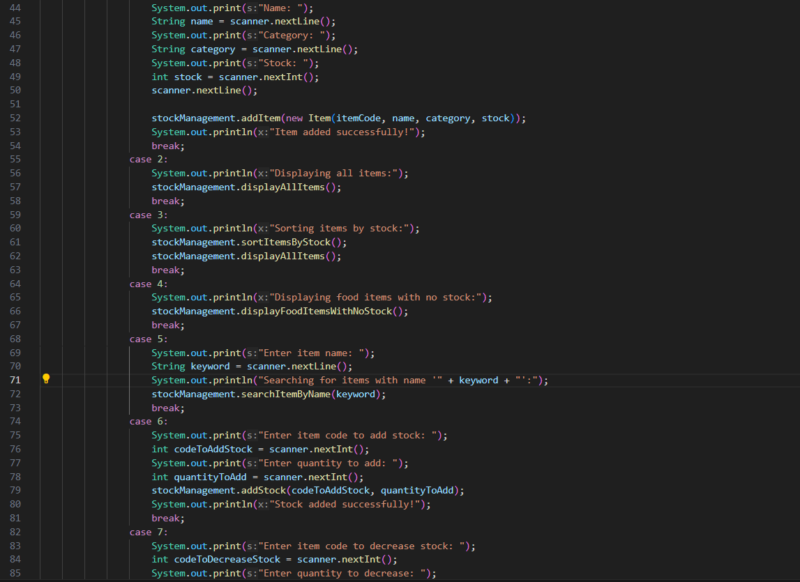 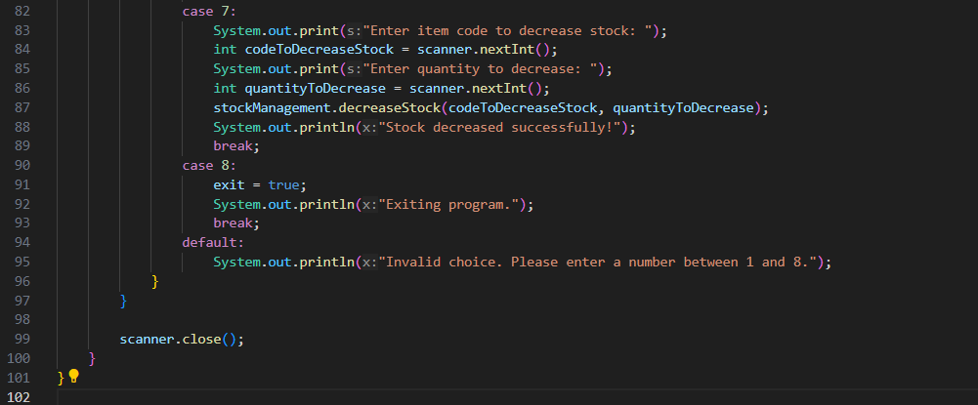

Output